

BSc (Hons) Ethical Hacking and Network Security

Higher National Diploma in Network Engineering (HNDNE)

HNDNE24.1F

**Cloud Computing - Coursework 2**

**Gajana Balachandran**

COHNDNE24.1F-046

# Ethical Declaration of Original Work

I declare that the work presented in this coursework is entirely my own. I confirm that:

1. The work presented in this coursework is conducted by me, and any contributions from other individuals are appropriately acknowledged.
2. Any external sources of information and ideas used in this work are cited and referenced accurately. I have provided proper credit to the original authors through citations in the text and a comprehensive list of references.
3. The data and findings presented in this work are genuine and have not been manipulated or fabricated. Any assistance received in the collection and analysis of data is acknowledged appropriately.
4. I have not submitted this work, or any part of it, for any other academic qualification.
5. I understand the ethical principles governing academic work, including honesty, integrity, and accountability. I have adhered to these principles throughout the process.

I am aware of the consequences of academic misconduct and understand that any violation of ethical standards may result in disciplinary action.

B. Gajana

2024/08/31

Table of Contents

Ethical Declaration of Original Work i

List of Tables iv

List of Figures v

Evaluation 1

IAM user account 1

1. Cloud concepts and architecture 2

B) Regions, Availability Zones, and Local/ Edge Zones 2

(C) Global, regional, and zonal resources 3

(D) Find the nearest Cloud Region Using a ping tool in the web 4

(E) Shortcomings of using a ping test to select a cloud region 6

2. Create a static webpage and host it on Cloud object storage 7

A) Screenshots of the bucket properties, bucket content and static website hosting configuration 7

B) Website URL and screenshots of both home and error pages 10

C) Screenshot of your active bucket policy 12

D) Is your website highly available? 13

3. Deploy and manage Cloud instances 15

A) Why a Virtual Network Segment is Required within a Cloud Environment 15

B) Screenshots of VPC details and subnets 15

C) Screenshots of your new routing table and final VPC resource map 18

D) Screenshots of at least four (04) essential steps) Create a Virtual Machine (Linux) in a public subnet of your custom VPC and connect with SSH key authentication 20

E) Screenshots of Install and run Apache with Placing index page and error page in Document Root 24

F) Clickable link and a screenshot of website 26

4. Cloud Security Concepts and Practices 31

A) Concept of Identity and Access Management (IAM). 31

B) Screenshots of account alias, users and permissions sections of the group Create IAM User 32

C) Why a group is preferred over directly granting permissions to a user 35

d. Principle of Least Privilege (PoLP) in cloud security and its impact on minimizing potential security threats 36

E) Points to improve the security of your website hosting setup created in the previous question 36

F) Observability and Accountability with examples and Audit trail in cloud services 37

References 39

# List of Tables

Table 1: IAM user account 5

Table 2: Regions 6

Table 3:Availability Zones 7

Table 4:URL for IAM users in this account 39

# List of Figures

Figure 1: AWS-Ping Test 10

Figure 2:AZURE – Ping Test 11

Figure 3: Create Bucket 13

Figure 4:Bucket Properties 13

Figure 5: Successful Bucket Message 14

Figure 6:static website hosting configuration 14

Figure 7:bucket content 15

Figure 8: bucket content upload 15

Figure 9: Home Page 16

Figure 10: Error Page 17

Figure 11: edit policy 18

Figure 12:active bucket policy 18

Figure 13: Create VPC 21

Figure 14: VPC Details 22

Figure 15: Subnet Screenshot 1 22

Figure 16: Subnet Screenshot 2 23

Figure 17: Subnet Screenshot 3 23

Figure 18: create new routing table 24

Figure 19: create internet gateway 24

Figure 20:final VPC resource map 25

Figure 21: launch instance 26

Figure 22: key pair config 26

Figure 23: network settings 27

Figure 24: create key pair 27

Figure 25: config storage instance 28

Figure 26: Putty config 28

Figure 27: Putty config 2 29

Figure 28: login instances 29

Figure 29:Install Apache 30

Figure 30:Create Index html 30

Figure 31:Create error html 31

Figure 32: edit inbound rules and security config 32

Figure 33:inbound rules and security config success 32

Figure 34: Allocating Elastic IP Address 33

Figure 35: Allocating Elastic IP Address Success 33

Figure 36: edit VPC settings 34

Figure 37: Instance Summary 34

Figure 38:Home Page on Elastic IP 35

Figure 39:Error Page on Elastic IP 36

Figure 40: Create IAM User 38

Figure 41: Create Alias 38

Figure 42: User details 39

Figure 43 :User created successfully 39

Figure 44: create user group and permission policies 40

Figure 45: permission set successfully for user group 40

# Evaluation

Evaluation requires the following IAM user created in your AWS account with specified permissions.

1. User: audit- nibm

2. Group: auditors241

3. Group privileges: Four (04) Policies - AmazonS3ReadOnlyAccess, AmazonEC2ReadOnlyAccess, AmazonVPCReadOnlyAccess, IAMReadOnlyAccess

# IAM user account

|  |  |
| --- | --- |
| AWS Account - Sign-in URL | https://010928198761.signin.aws.amazon.com/console |
| IAM User | audit-nibm |
| Password | Gaana241F* |

Table 1: IAM user account

# 1. Cloud concepts and architecture

(A) Cloud provider's global infrastructure

Global infrastructure for cloud providers includes a wide range of data centers with servers, network resources, edge locations, and content delivery networks (CDNs) spread over different regions, availability zones (AZs), and continents globally. The provision of services like networking, storage, and processing power is made possible by this massive infrastructure, which gives users access to these resources anywhere in the world.

## B) Regions, Availability Zones, and Local/ Edge Zones

**Regions:**

* The infrastructure of cloud providers is divided into regions, which are broad geographical areas with several data centers.

|  |  |
| --- | --- |
| In Amazon Web Services (AWS) | Ap east 1 (Asia Pacific-Hong Kong)  Ap southeast 3(Asia Pacific-Jakarta)  Ap southeast 1(Asia Pacific-Singapore)  Eu west 1 (Europe-Ireland)  Eu south 2 (Europe-Spain) |

Table 2: Regions

**Availability Zones:**

* There are several availability zones (AZs) within each region. A zone's isolated data centers, or AZs, are built to withstand the failures of surrounding AZs.

|  |  |  |
| --- | --- | --- |
| Amazon Web Services (AWS) | Asia Pacific (Tokyo) | ap-northeast-1a  ap-northeast-1b  ap-northeast-1c |
| US West (Oregon) | us-west-2a  us-west-2b  us-west-2c |
| US East (N. Virginia) | us-east-1a  us-east-1b  us-east-1c |

Table 3:Availability Zones

**Edge Locations:**

* In order to bring content closer to end users, minimize delay, and improve service performance, edge sites are spread throughout the world.

Example:

* AWS Local Zones
* AWS Outposts
* AWS Wavelength
* AWS Snow Family Amazon CloudFront

## (C) Global, regional, and zonal resources

**Global Resources:**

Cloud resources that are not restricted to a particular location or availability zone are known as global resources. They can be used and shared globally since they are managed and available from anywhere in the world.

* **Content Delivery Network (CDN)**
* **Global Load Balancers**
* **Global Database Services**
* **Identity and Access Management (IAM)**
* **Global File Storage**
* **Global Monitoring and Logging**

**Regional Resources:**

Cloud resources that are deployed and managed inside a particular region are known as regional resources. These resources may help with privacy and security needs because they are restricted to that region, meaning that they are only accessible inside its borders.

* **Virtual Machines (VMs)**
* **Managed Databases**
* **Object Storage**
* **Compute Engine**
* **Networking Services**

**Zonal Resources:**

Cloud resources categorized as "zonal" are associated with a certain availability zone in a given location. Because workloads are distributed throughout several zones, these resources—which are restricted to that specific zone—offer redundancy and fault tolerance.

* **Amazon SageMaker Instances**
* **Amazon RDS (Relational Database Service) Instances**
* **AWS EC2 Instances**
* **Amazon EBS (Elastic Block Store) Volumes**

## (D) Find the nearest Cloud Region Using a ping tool in the web

**AWS-Ping Test**

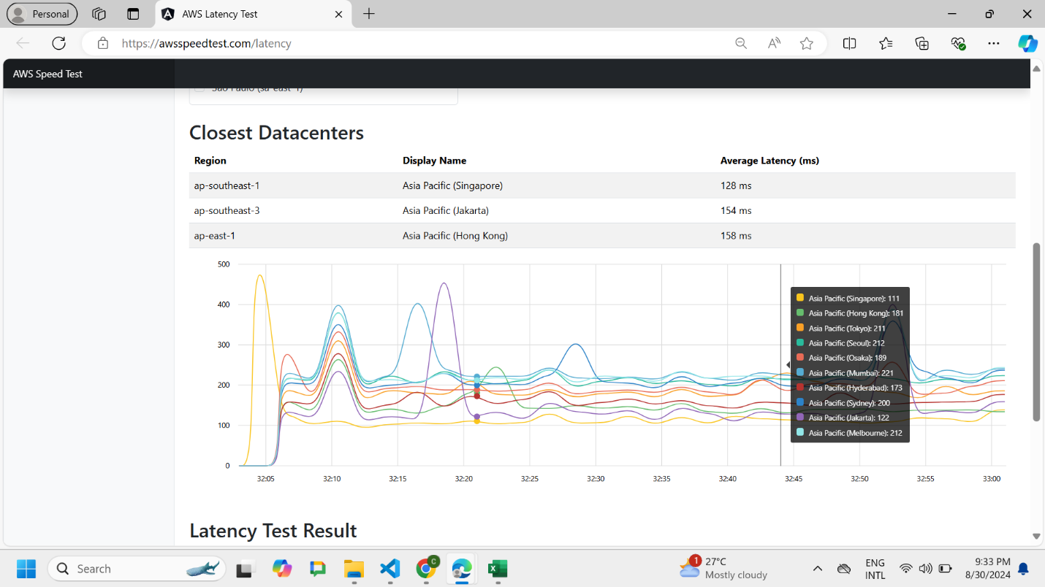

Figure 1: AWS-Ping Test

**AZURE – Ping Test**

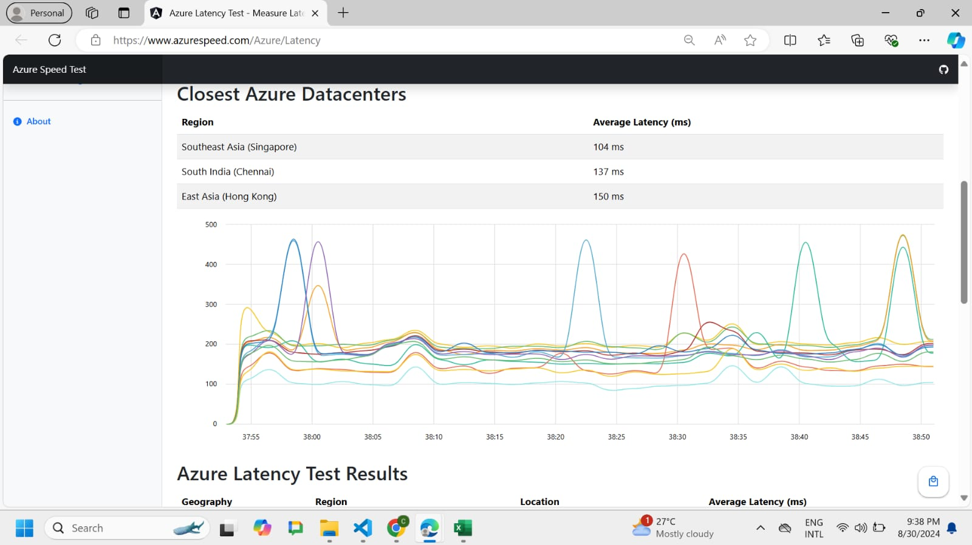

Figure 2:AZURE – Ping Test

## (E) Shortcomings of using a ping test to select a cloud region

**1. Ignores Requirements Specific to Each Application**

Beyond low latency, applications have unique requirements. For example, compliance-driven apps may need to take legal restrictions and data ownership into account in addition to performance, while apps that use data might value bandwidth above latency.

**2. Limited Assessment Scope**

The time it takes for a little data packet to go from your location to the cloud area and back is known as network latency, and this is what ping tests exclusively measure.

**3. Variance in the latency**

Many reasons, including increased traffic, route modifications, and temporary outages, can cause changes in network conditions.

# 2. Create a static webpage and host it on Cloud object storage

## A) Screenshots of the bucket properties, bucket content and static website hosting configuration

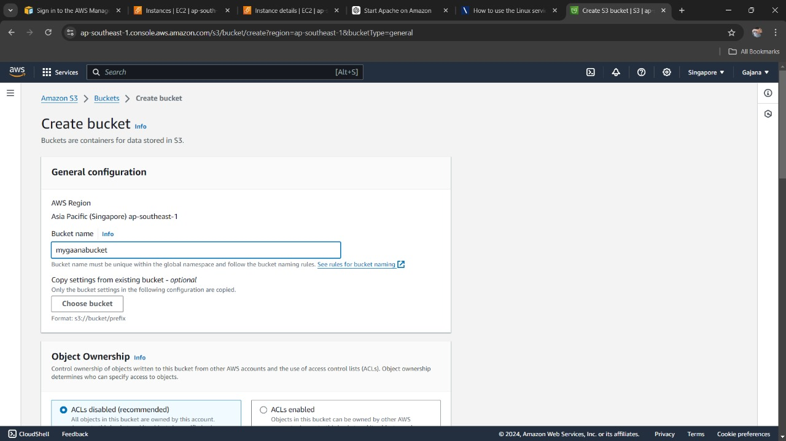

Figure 3: Create Bucket

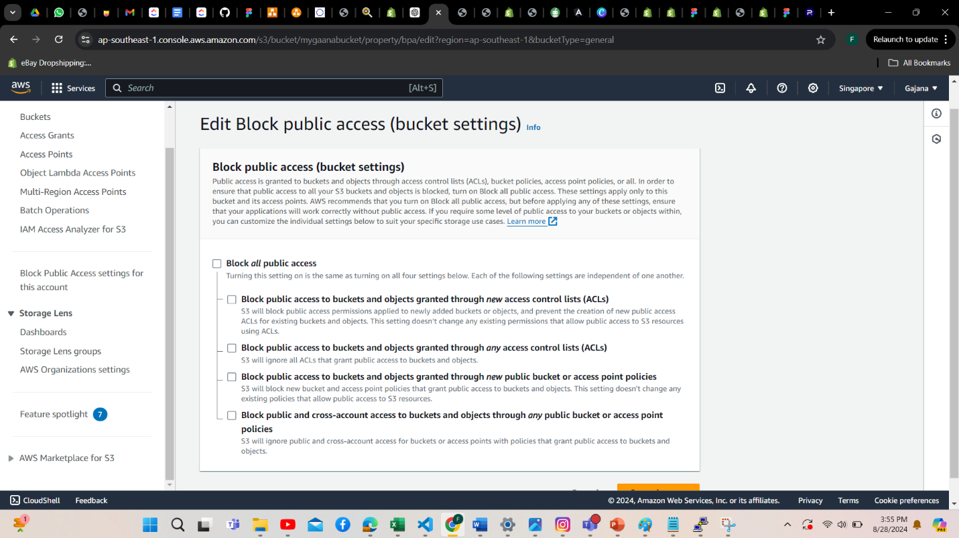

Figure 4:Bucket Properties

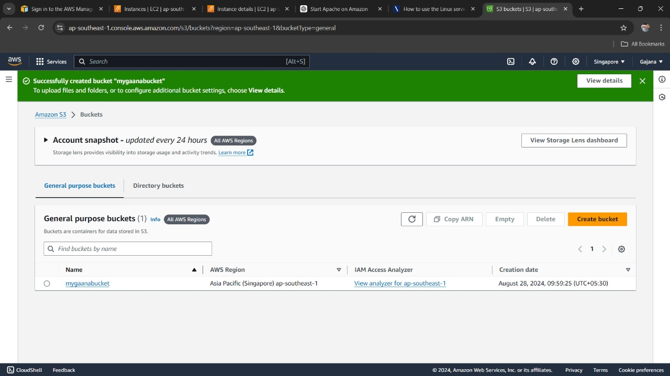

Figure 5: Successful Bucket Message

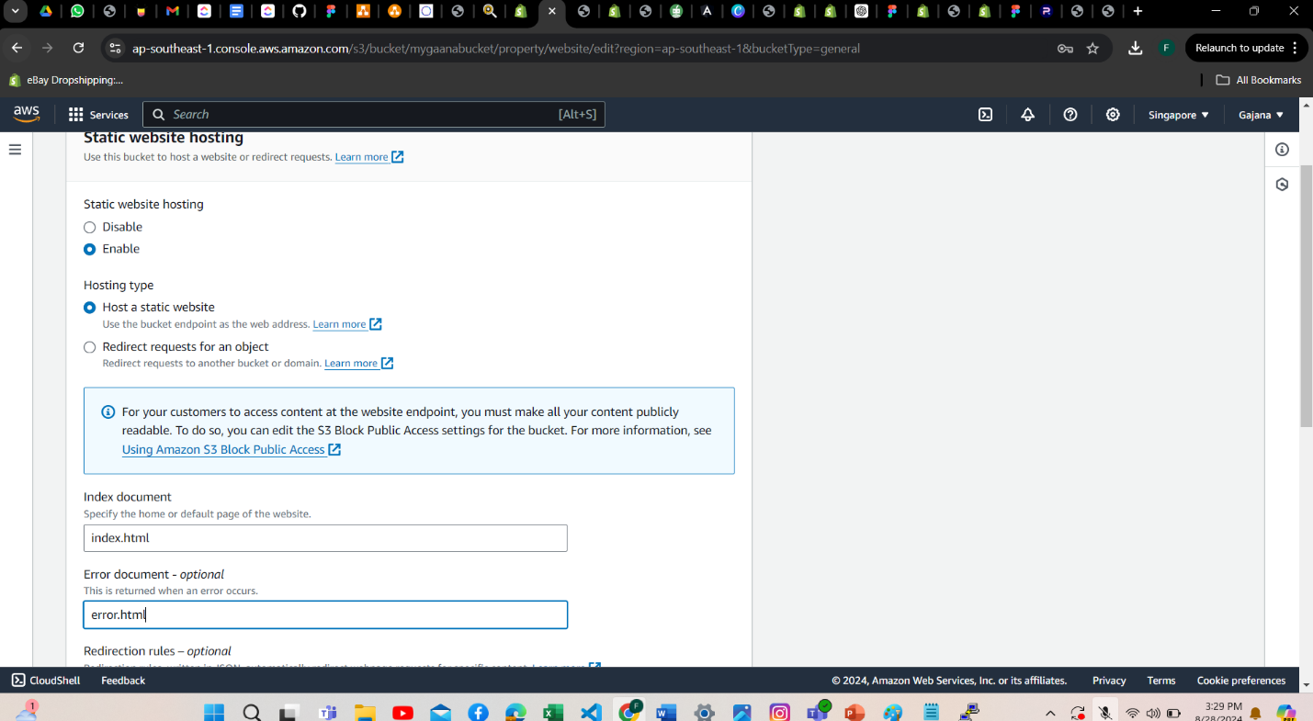

Figure 6:static website hosting configuration

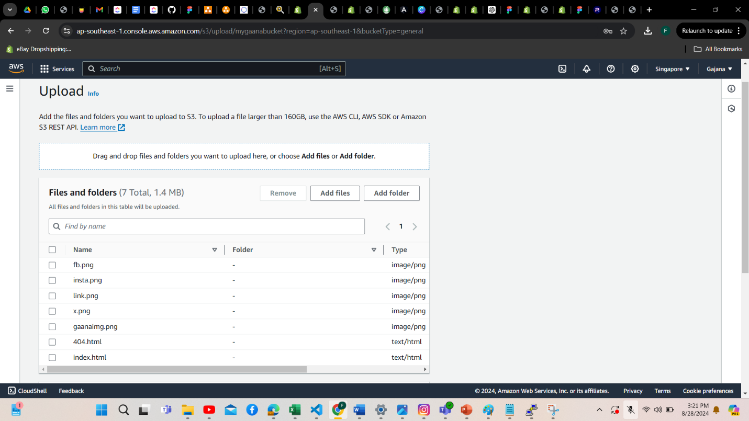

Figure 7:bucket content

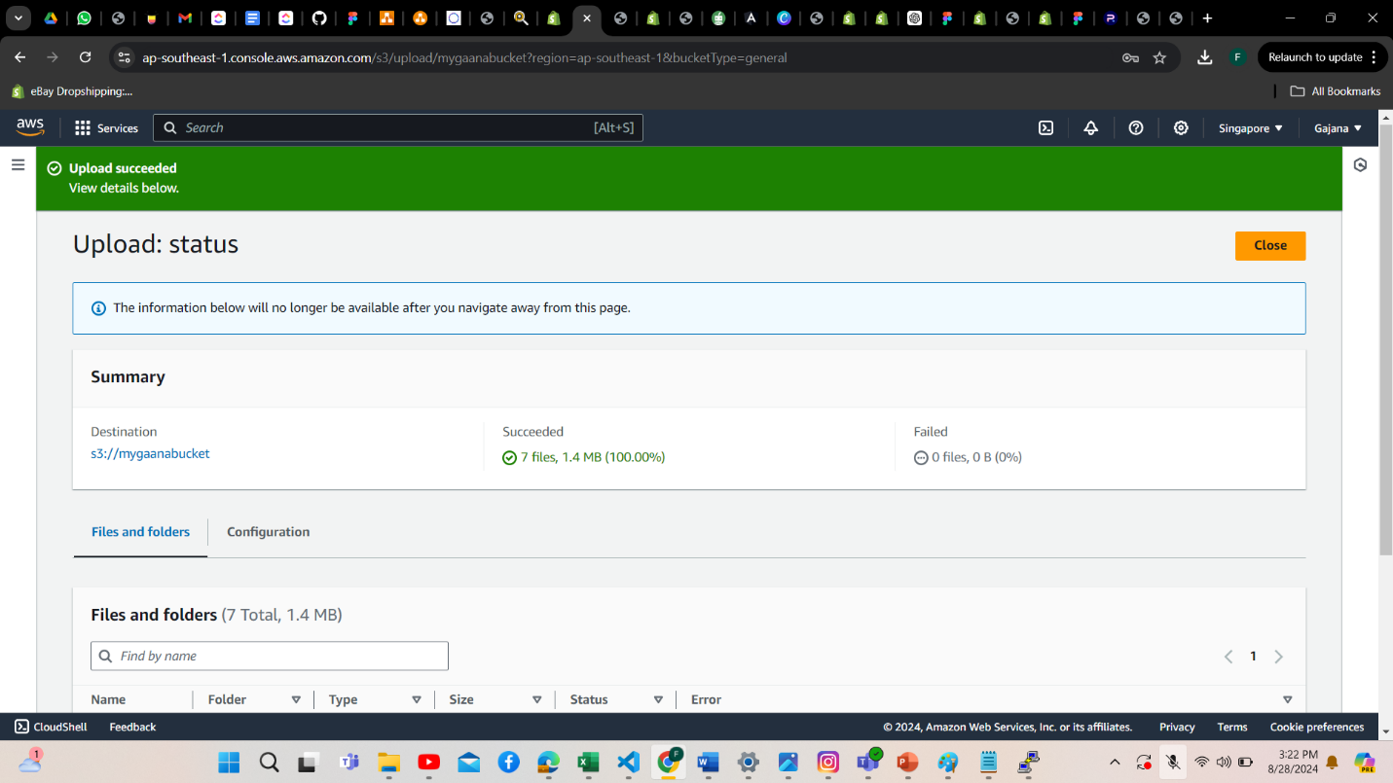

Figure 8: bucket content upload

## B) Website URL and screenshots of both home and error pages

<http://mygaanabucket.s3-website-ap-southeast-1.amazonaws.com/>

<http://mygaanabucket.s3-website-ap-southeast-1.amazonaws.com/error/>

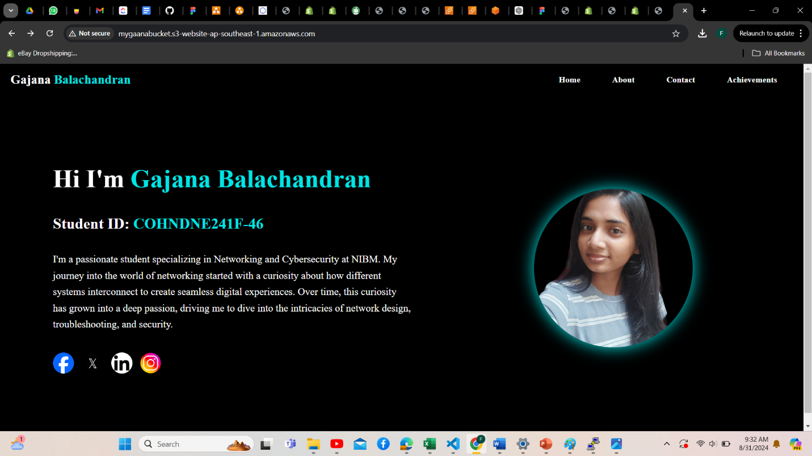

Figure 9: Home Page

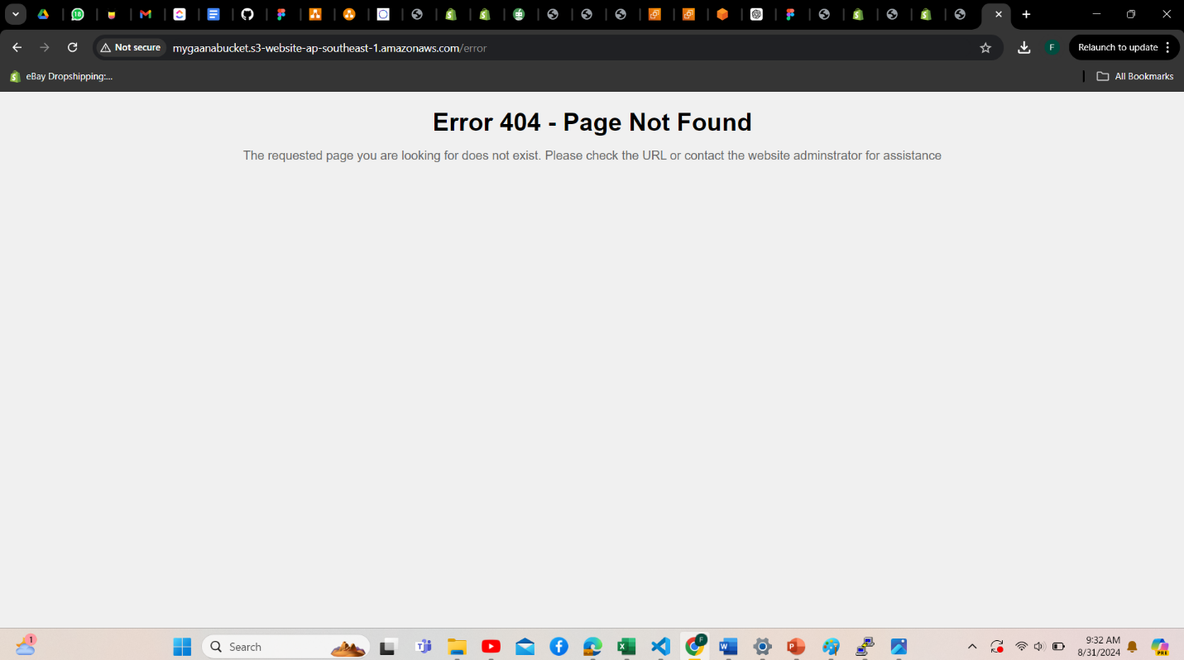

Figure 10: Error Page

## C) Screenshot of your active bucket policy

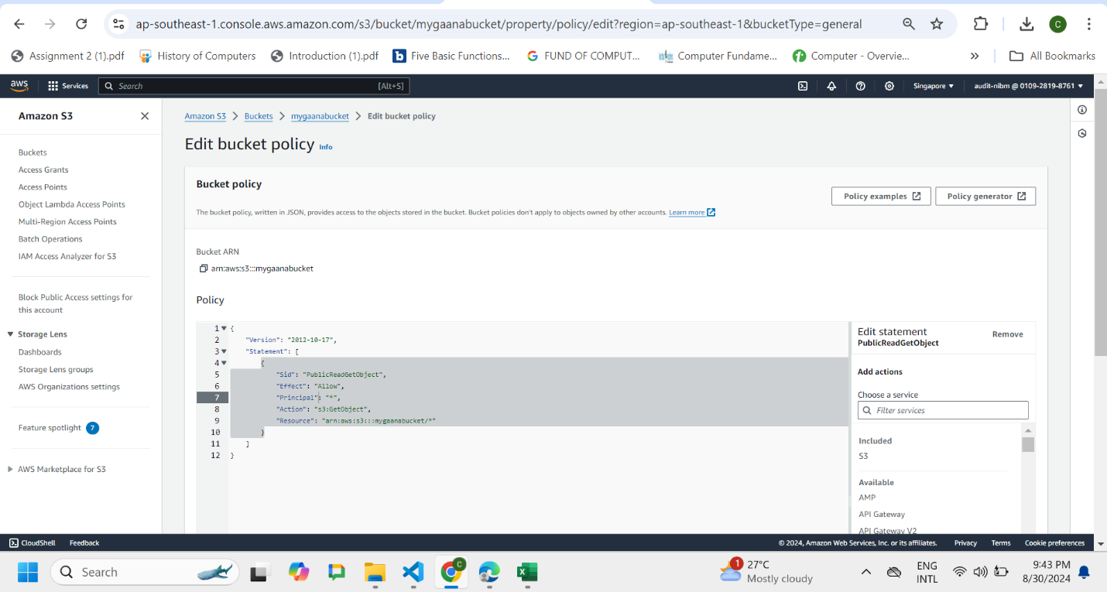

Figure 11: edit policy

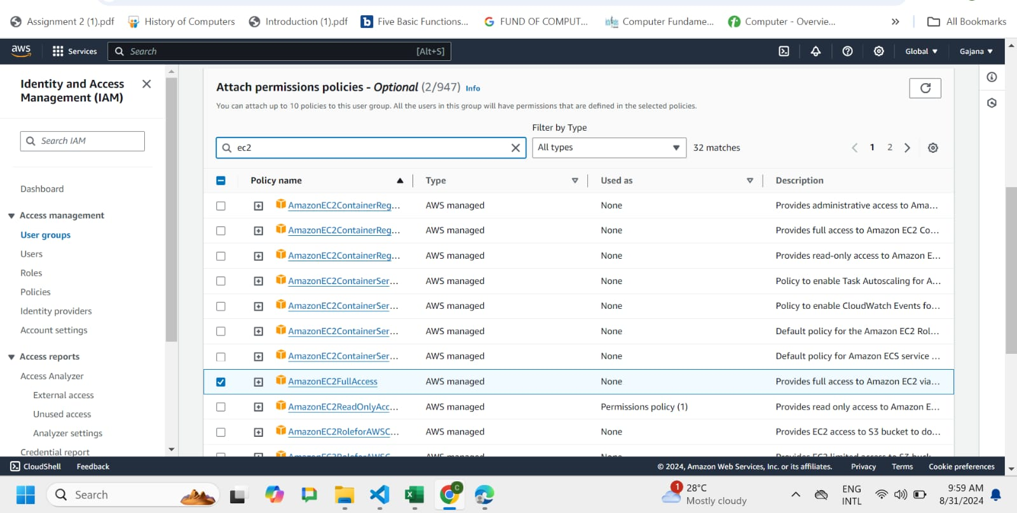

Figure 12:active bucket policy

## D) Is your website highly available?

Yes, the static website hosted on Cloud Object Storage is highly available. Here are two distinct points to justify this:

1. **Redundancy and Replication Across Multiple Availability Zones:**

Within a region, data is stored across different availability zones by cloud providers such as AWS, Azure, and Google Cloud. This implies that the data can still be accessed from another availability zone in the event that one goes down. The website will always be accessible thanks to this replication, even in the event of hardware malfunctions or other problems in a particular zone.

1. **Content Delivery Network (CDN) Integration:**

A Content Delivery Network (CDN), such as Amazon CloudFront, Azure CDN, or Google Cloud CDN, can be linked with the majority of cloud storage providers. By caching the material at edge points spread throughout the world, a CDN guarantees availability and speedier load times. End users can continue to receive high availability and performance from any location in the event that one CDN node fails by having their requests forwarded to the next closest node.

# 3. Deploy and manage Cloud instances

## A) Why a Virtual Network Segment is Required within a Cloud Environment

1. **Isolation and Security:**

**Isolation:** You can separate your resources within the cloud using virtual networks, such as Google VPC, Amazon VPC, and Azure VNet. The maintenance of reliable and secure operations depends on the ability of various environments (such as development, testing, and production) to function independently and without interference. This is ensured by the isolation.

**Security:** You can apply network security controls like firewalls and security groups, enforce security policies, and manage traffic flow by establishing virtual network segments. By doing this, important information and apps are shielded from potential security risks and unwanted access.

1. **Efficient Resource Management and Connectivity:**

**Resource Management:** Cloud resource management and organization are made possible by virtual network segments. It is simpler to administer and keep an eye on relevant resources when they are grouped together within the same network segment.

**Connectivity:** They make it possible for various cloud resources, like virtual machines, databases, and storage services, to connect with ease. Furthermore, virtual networks enable reliable and secure access to crucial corporate applications and data by facilitating secure connections to on-premises data centers via VPN or Direct Connect services.

## B) Screenshots of VPC details and subnets

**VPC Details**

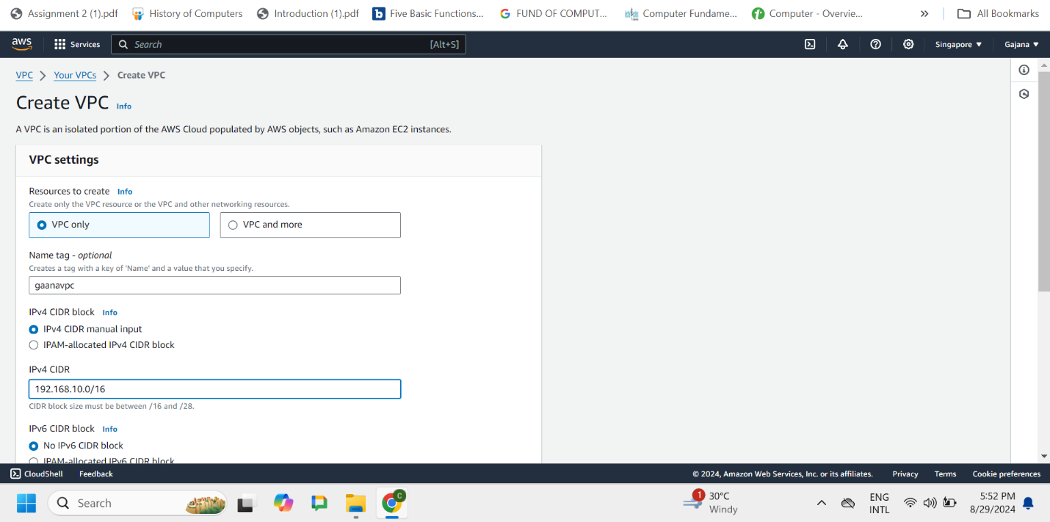

Figure 13: Create VPC

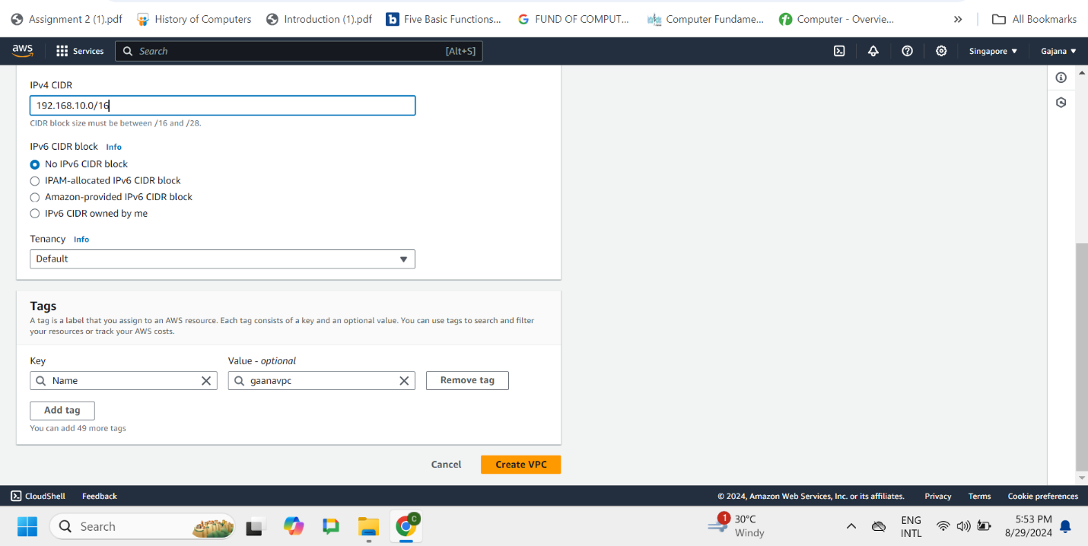

Figure 14: VPC Details

**Subnets**

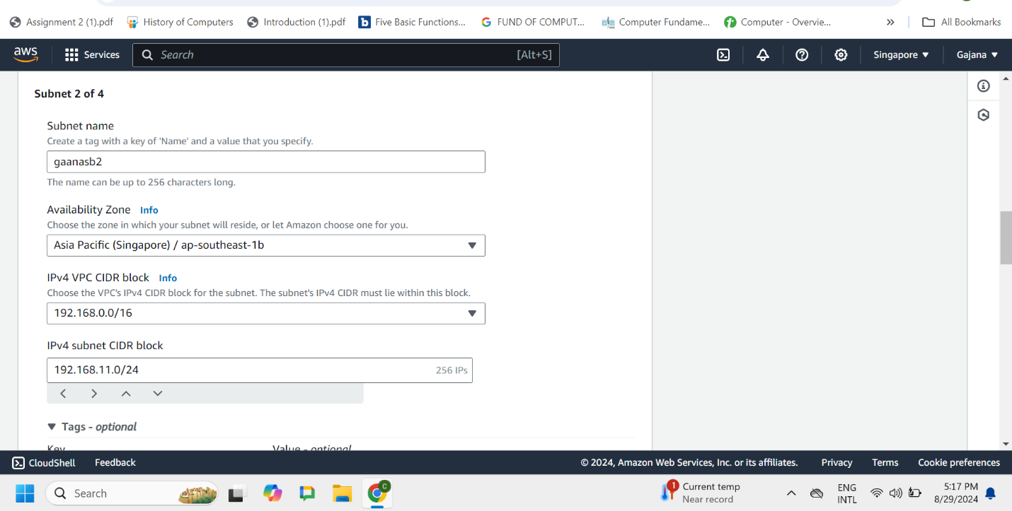

Figure 15: Subnet Screenshot 1

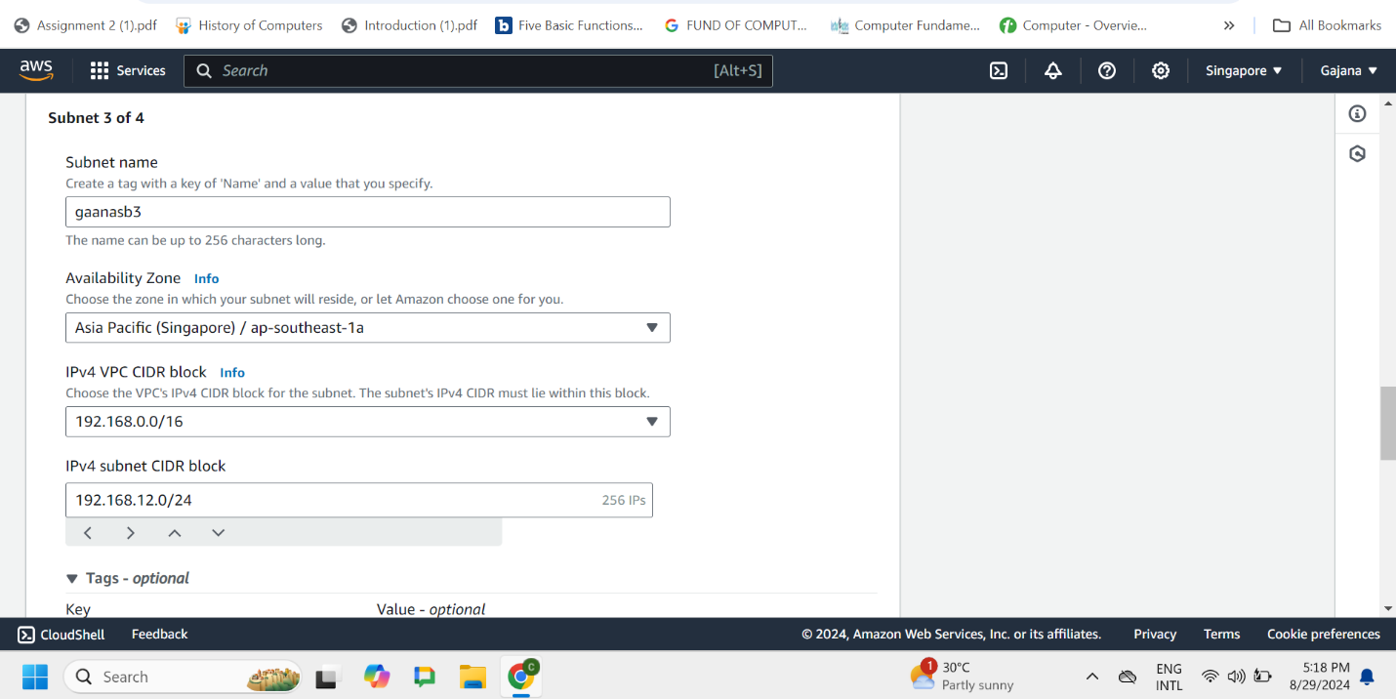

Figure 16: Subnet Screenshot 2

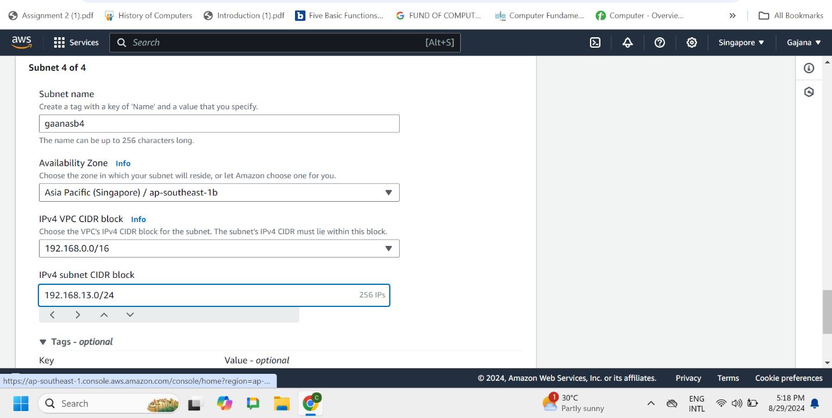

Figure 17: Subnet Screenshot 3

## C) Screenshots of your new routing table and final VPC resource map

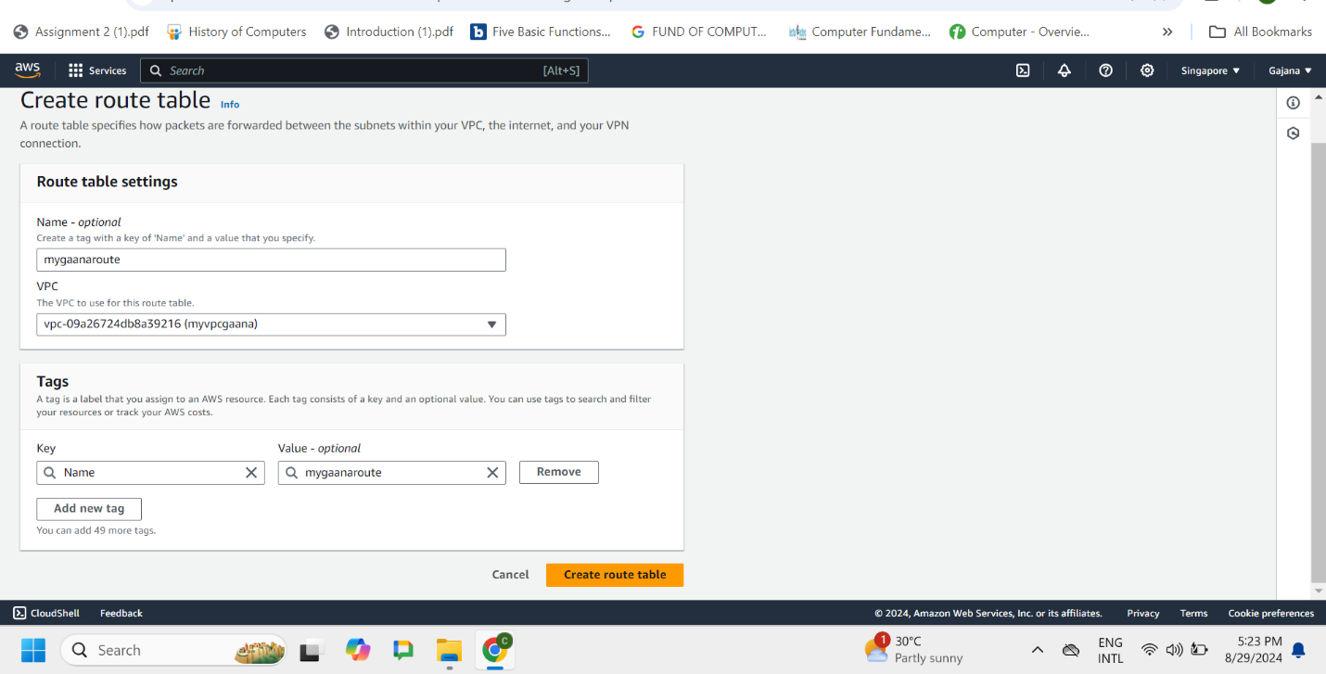

Figure 18: create new routing table

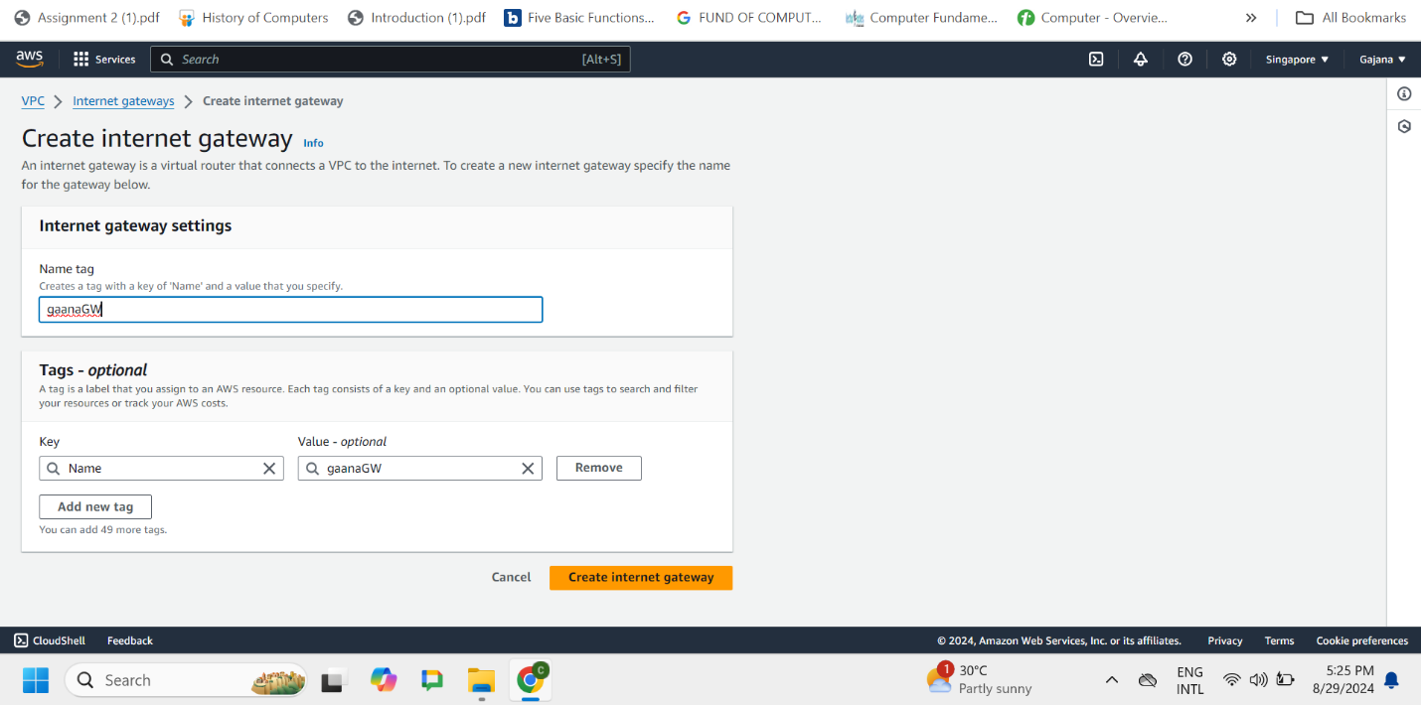

Figure 19: create internet gateway

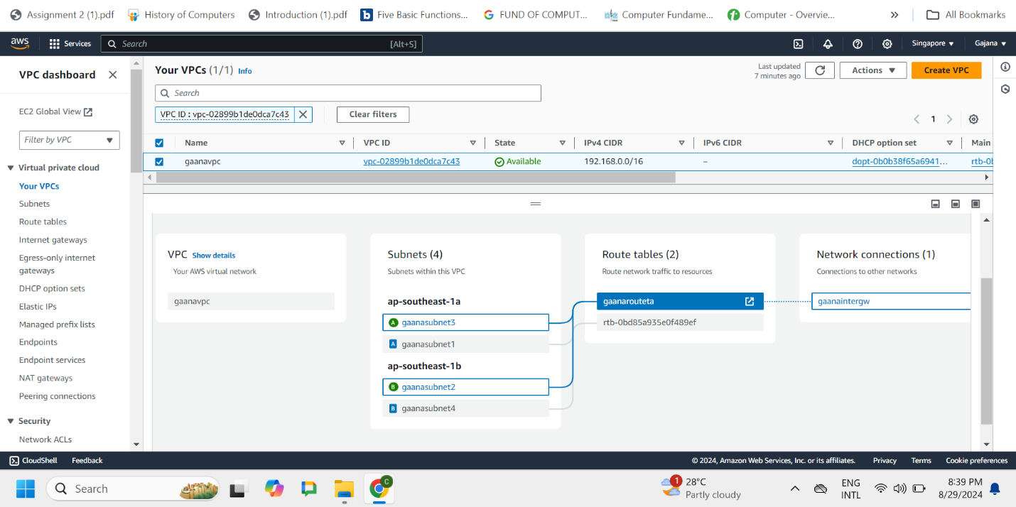

Figure 20:final VPC resource map

## D) Screenshots of at least four (04) essential steps) Create a Virtual Machine (Linux) in a public subnet of your custom VPC and connect with SSH key authentication

**Create instance**

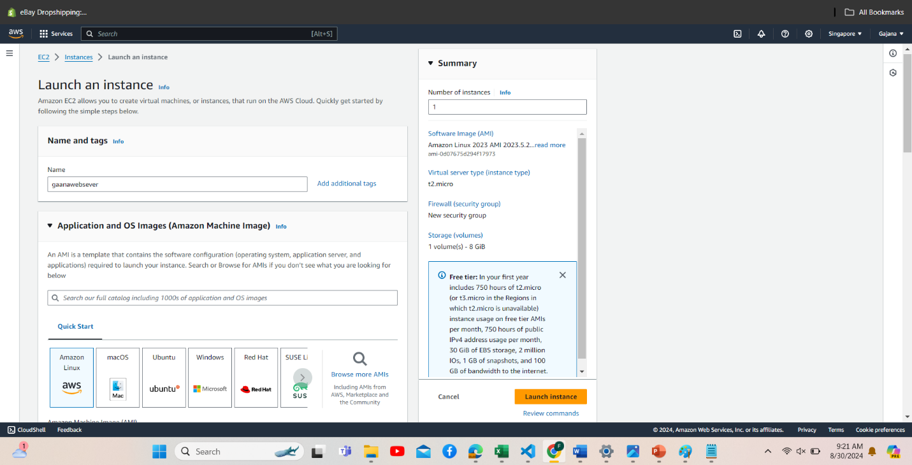

Figure 21: launch instance

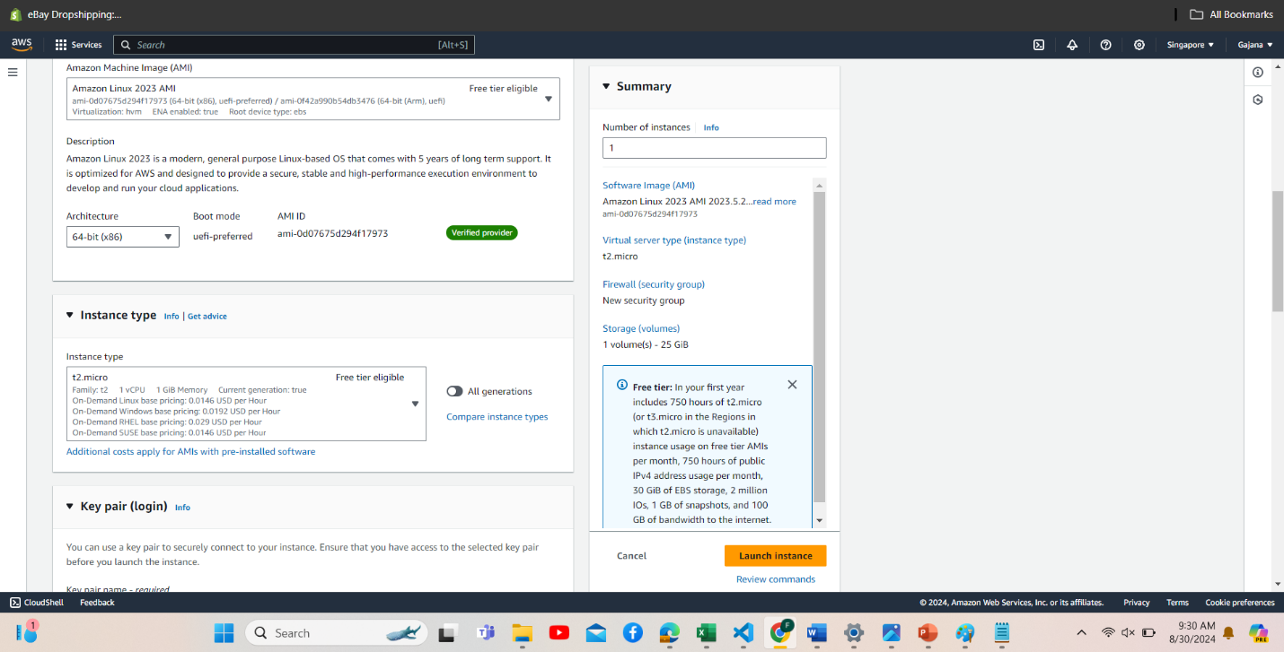

Figure 22: key pair config

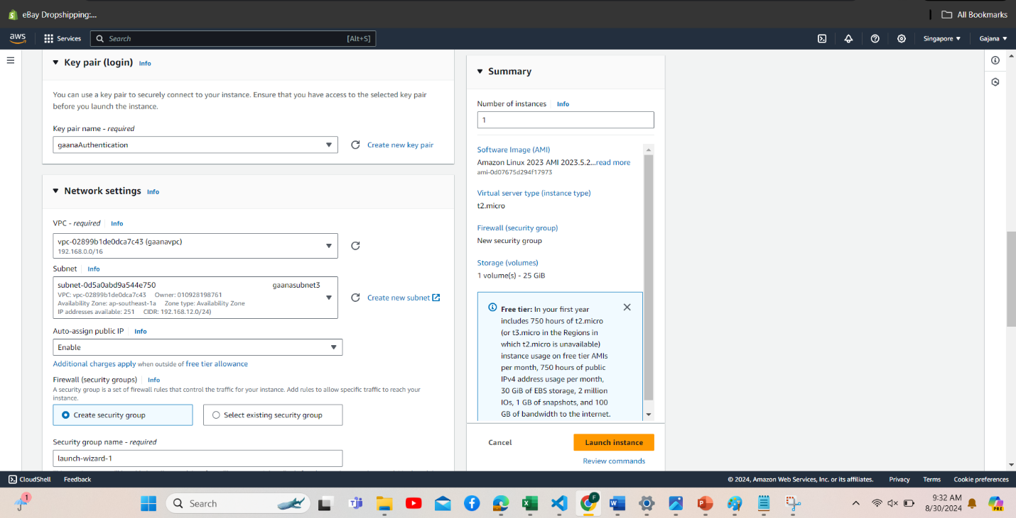

Figure 23: network settings

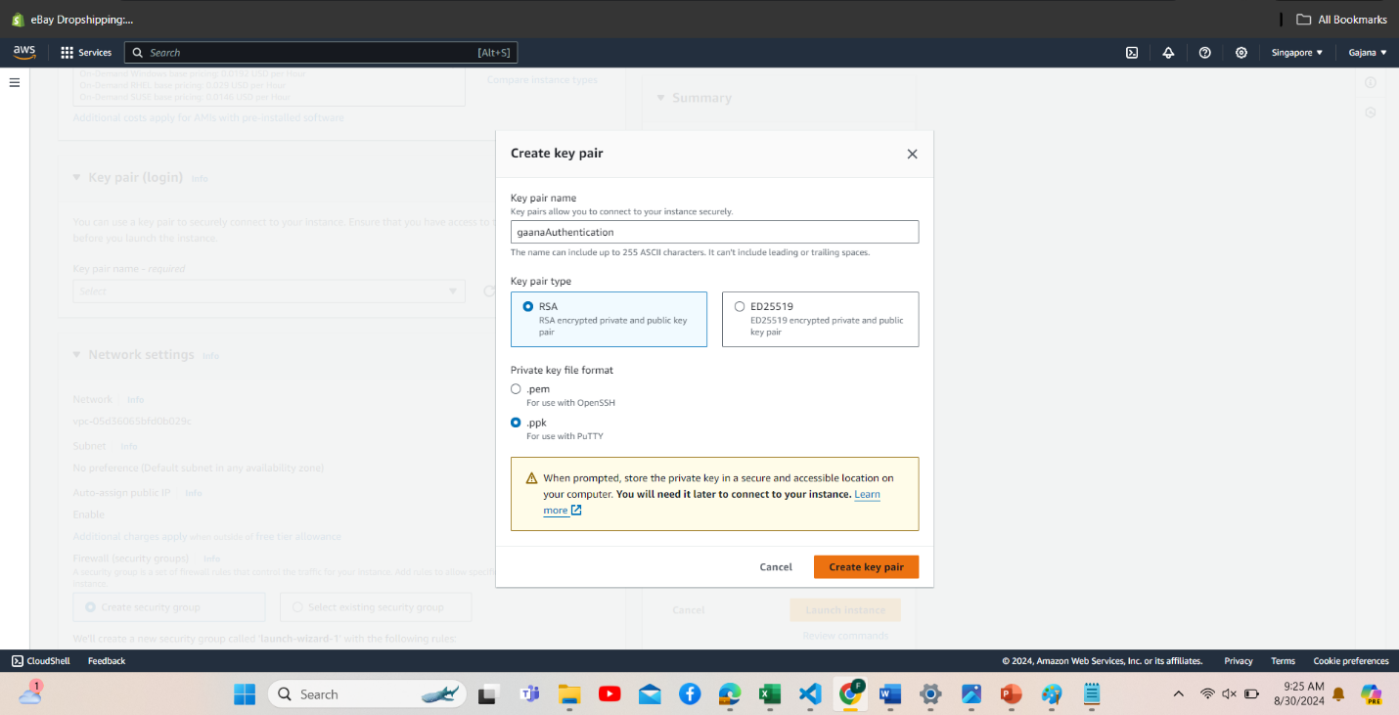

Figure 24: create key pair

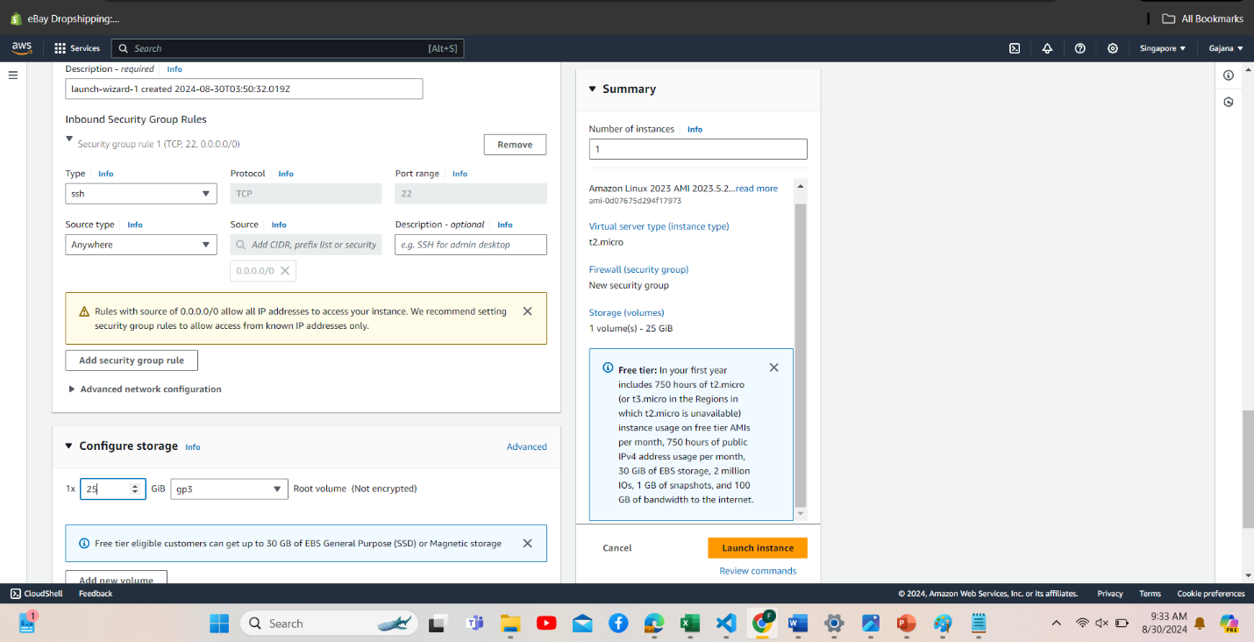

Figure 25: config storage instance

**Login instance**

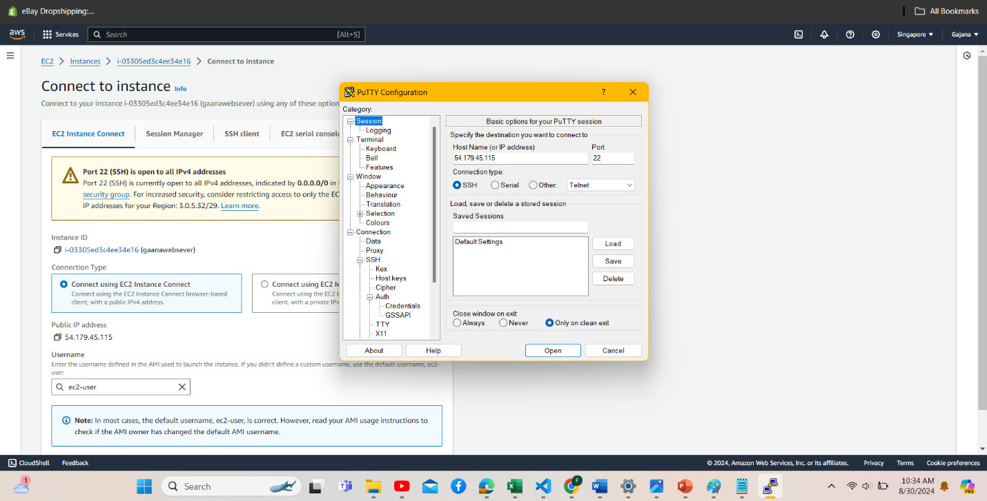

Figure 26: Putty config

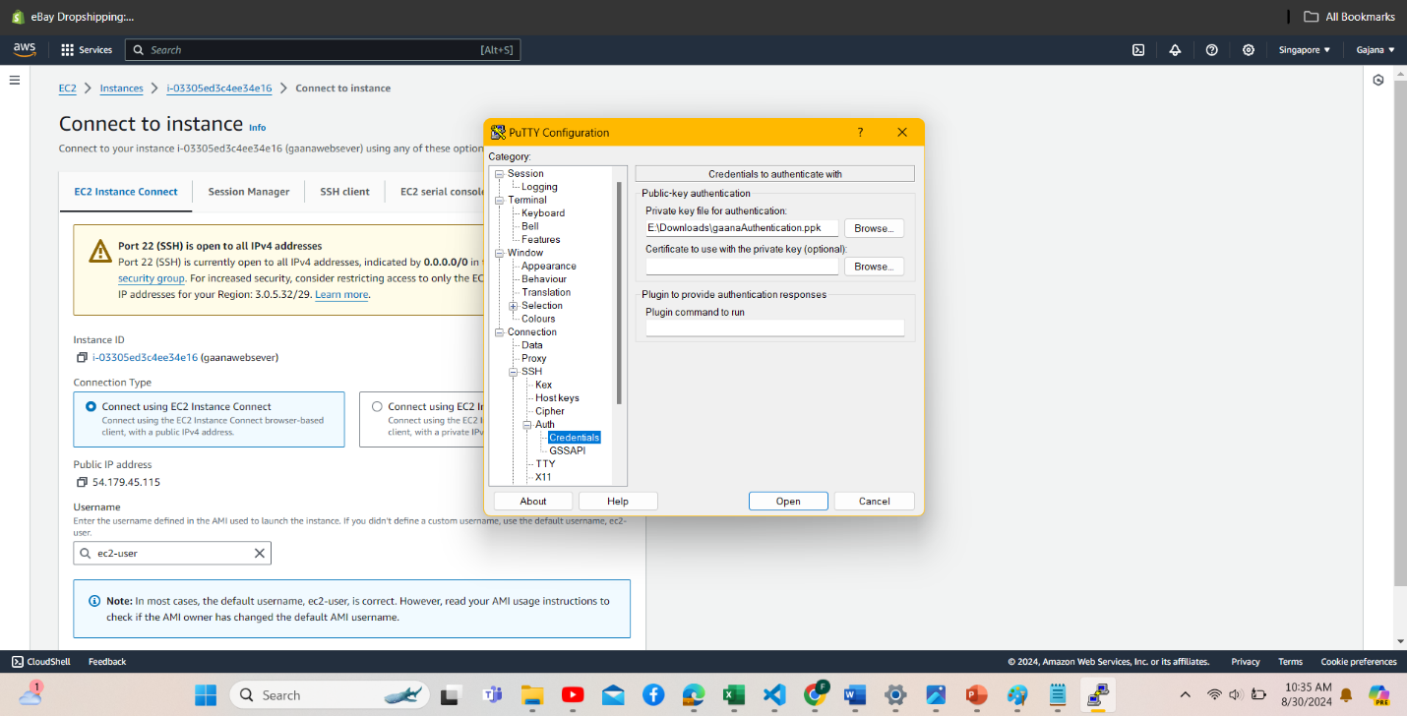

Figure 27: Putty config 2

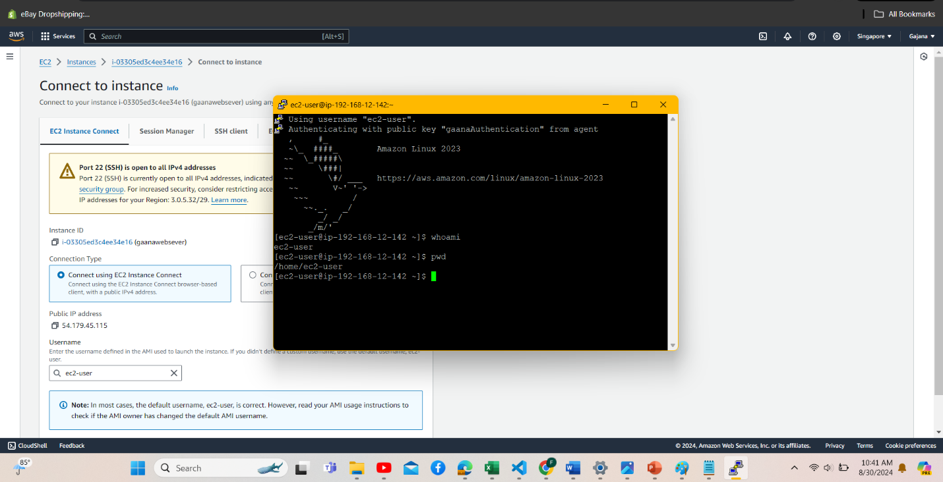

Figure 28: login instances

## E) Screenshots of Install and run Apache with Placing index page and error page in Document Root

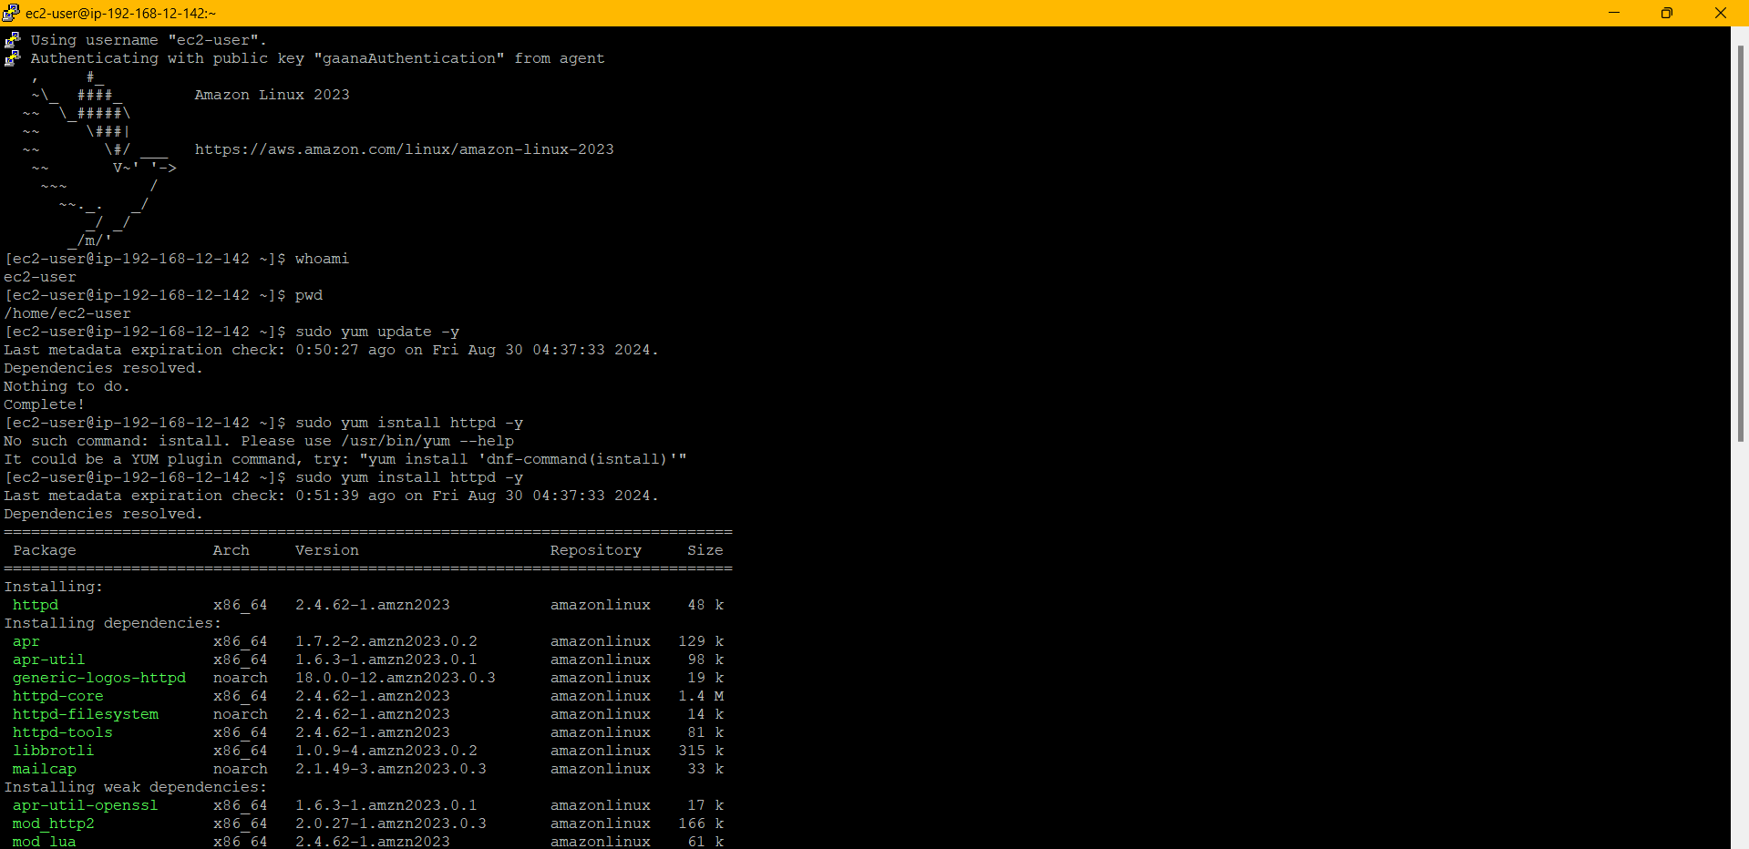

Figure 29:Install Apache

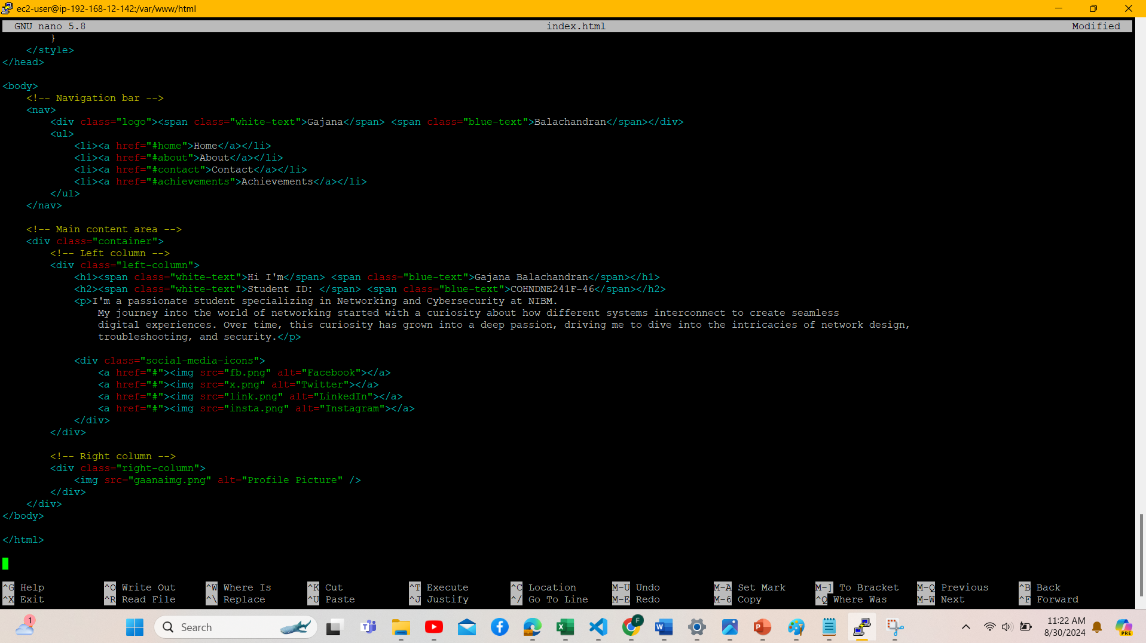

Figure 30:Create Index html

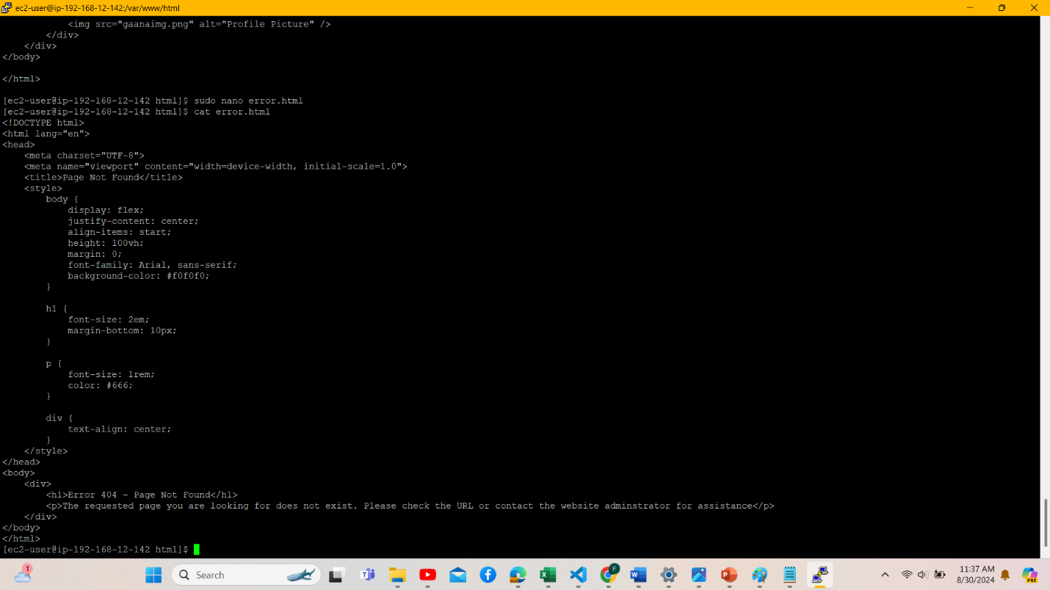

Figure 31:Create error html

## F) Clickable link and a screenshot of website

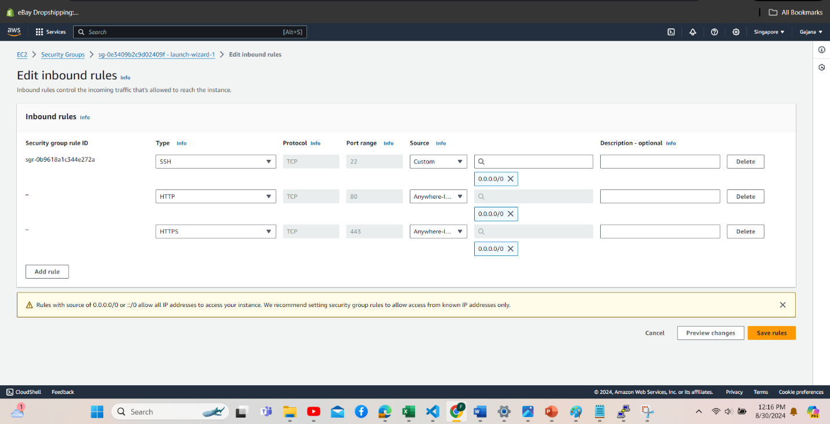

Figure 32: edit inbound rules and security config

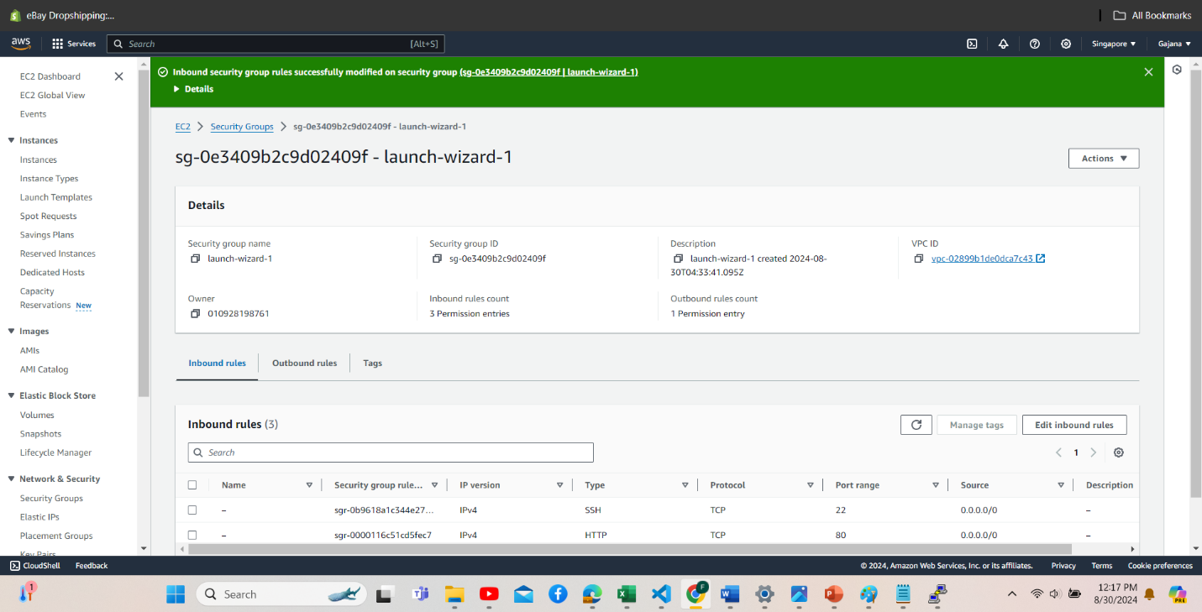

Figure 33:inbound rules and security config success

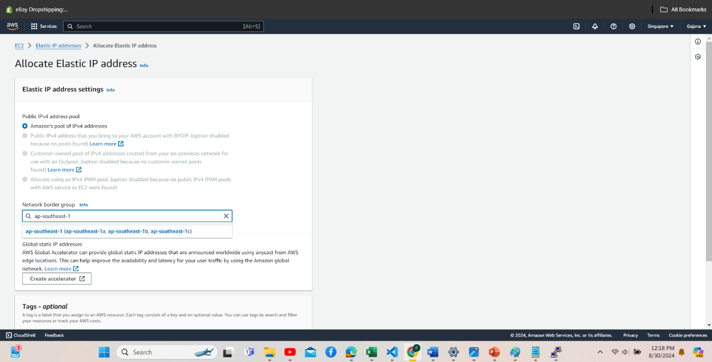

Figure 34: Allocating Elastic IP Address

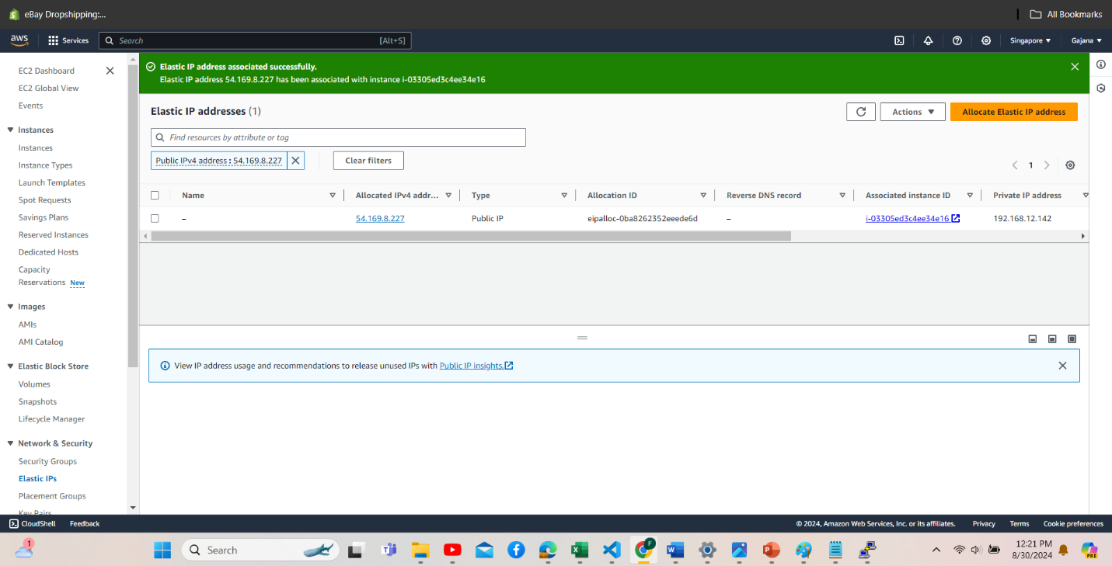

Figure 35: Allocating Elastic IP Address Success

**Enable DNS Hostname**

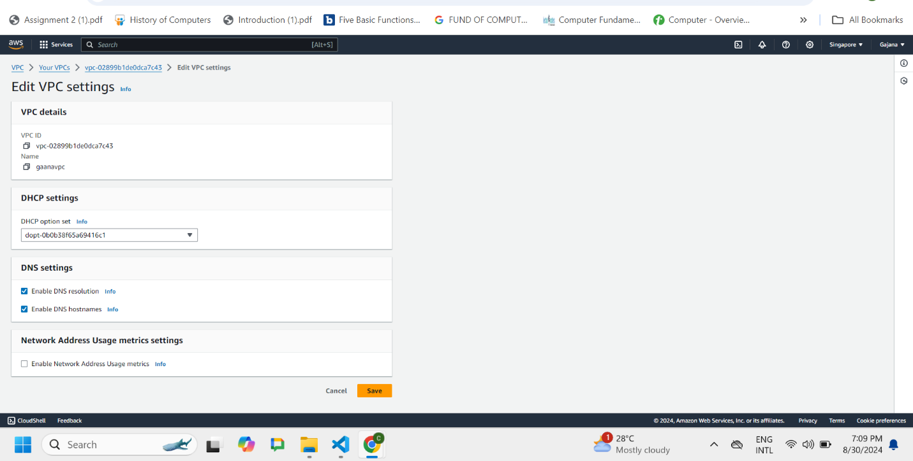

Figure 36: edit VPC settings

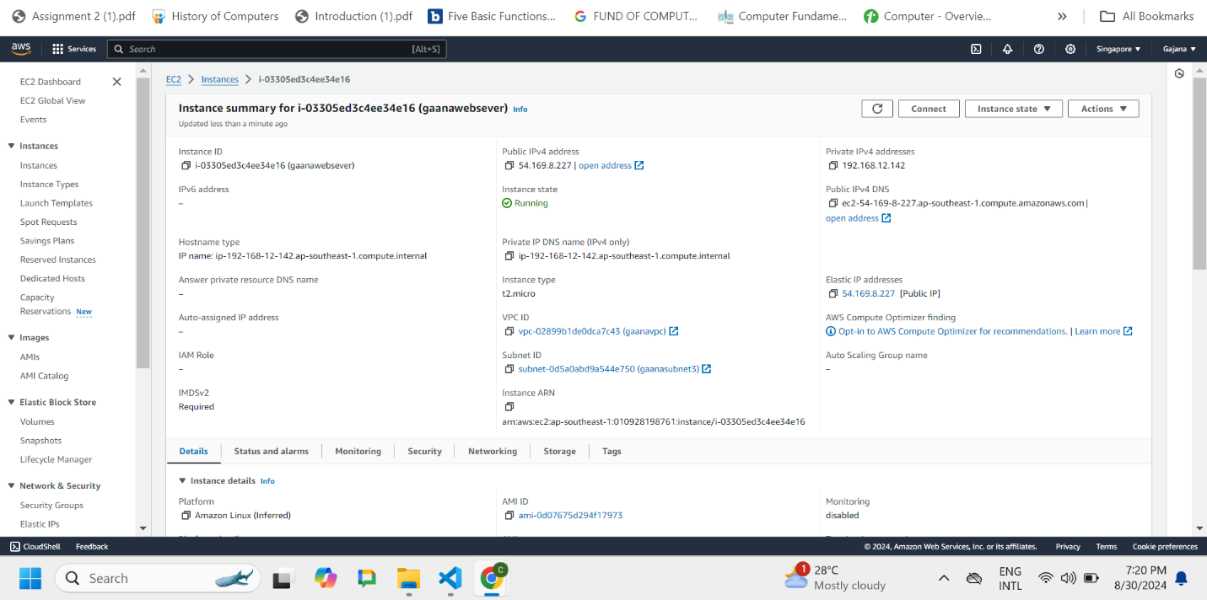

Figure 37: Instance Summary

**Clickable Link on Elastic Ip**

<http://54.169.8.227/index.html>

<http://54.169.8.227/error.html>

**Clickable Link on Public Ipv4 DNS**

<http://ec2-54-169-8-227.ap-southeast-1.compute.amazonaws.com/index.html>

<http://ec2-54-169-8-227.ap-southeast-1.compute.amazonaws.com/error.html>

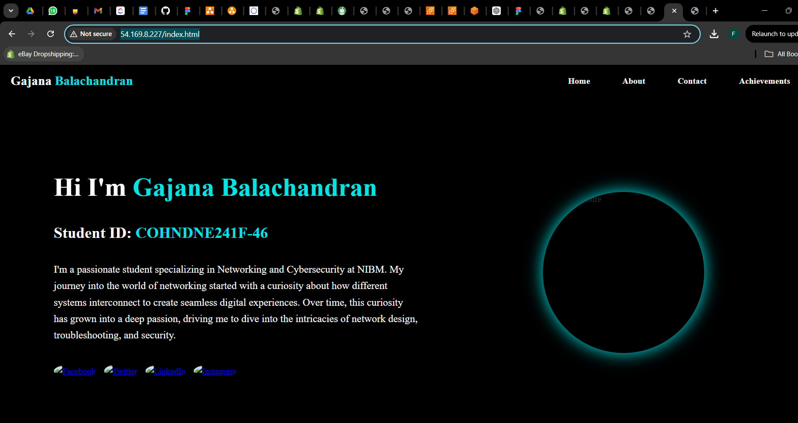

Figure 38:Home Page on Elastic IP

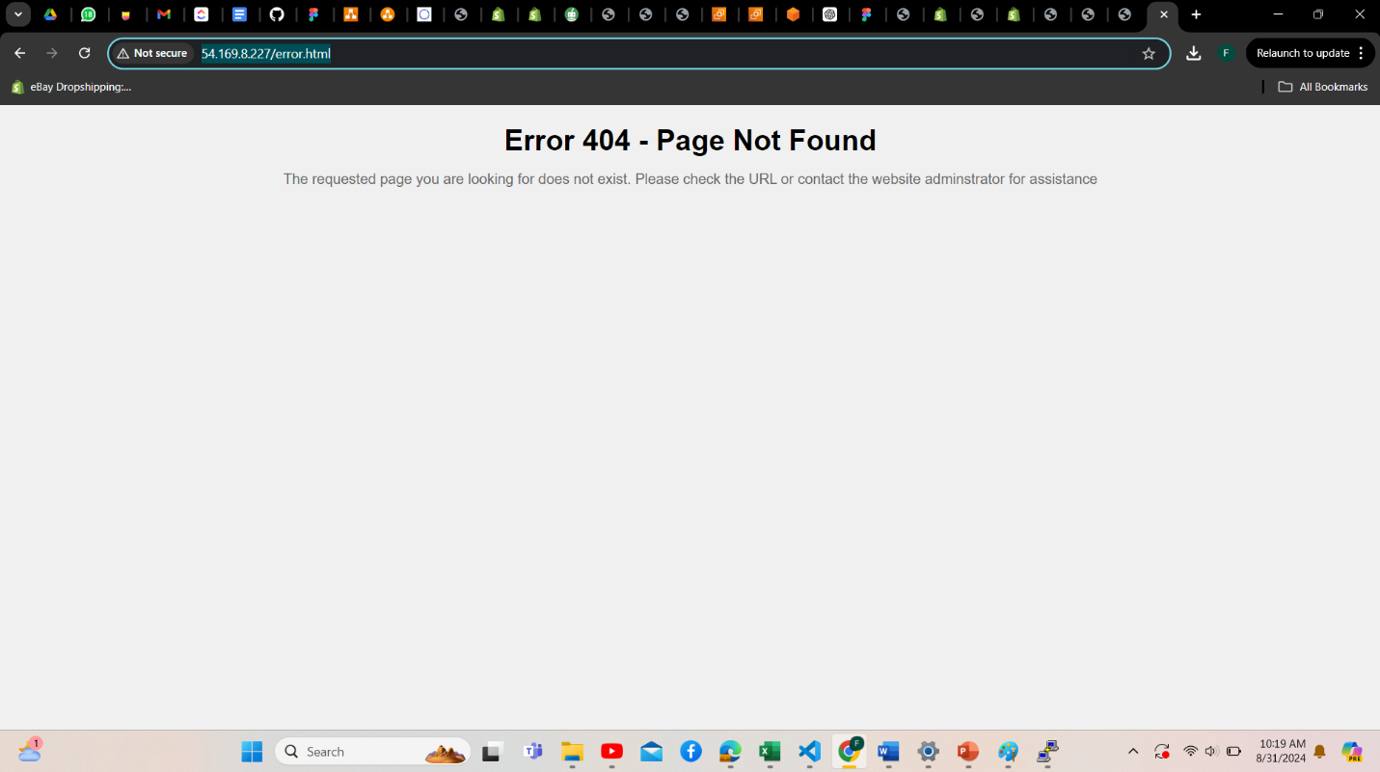

Figure 39:Error Page on Elastic IP

4. Cloud Security Concepts and Practices

## A) Concept of Identity and Access Management (IAM).

A full system called Identity and Access Management (IAM) is often used in cloud-based environments to handle and limit user access to important resources. To make sure that only those with authorization can access particular resources, identity management, role assignment, and authorization monitoring are all part of identity and access management (IAM). It includes authorization standards to specify what actions users are permitted to take and authentication techniques to confirm user identities.

IAM is essential for maintaining security in a cloud environment because it enables companies to apply the Principle of Least Privilege (PoLP), which guarantees that users have the minimal amount of access required to complete their jobs. IAM reduces the possibility of security problems, including data leaks or illegal access to private data, by carefully controlling roles and permissions. In addition to safeguarding resources, this methodical technique helps in upholding compliance to rules and industry standards.

## B) Screenshots of account alias, users and permissions sections of the group Create IAM User

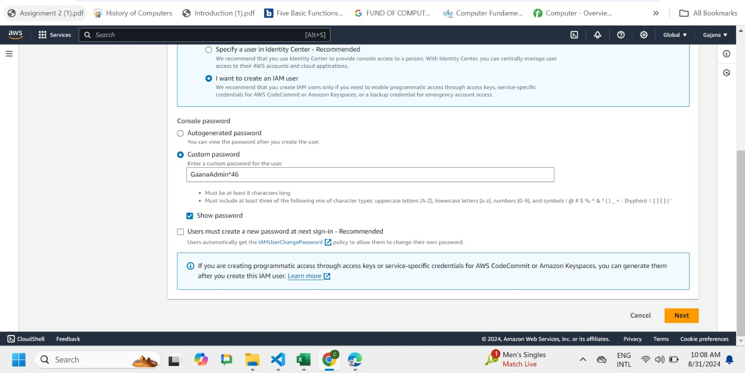

Figure 40: Create IAM User

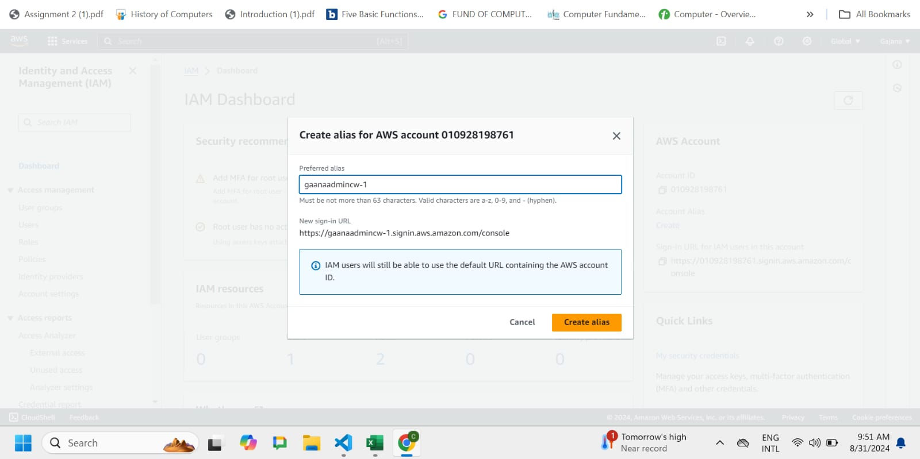

Figure 41: Create Alias

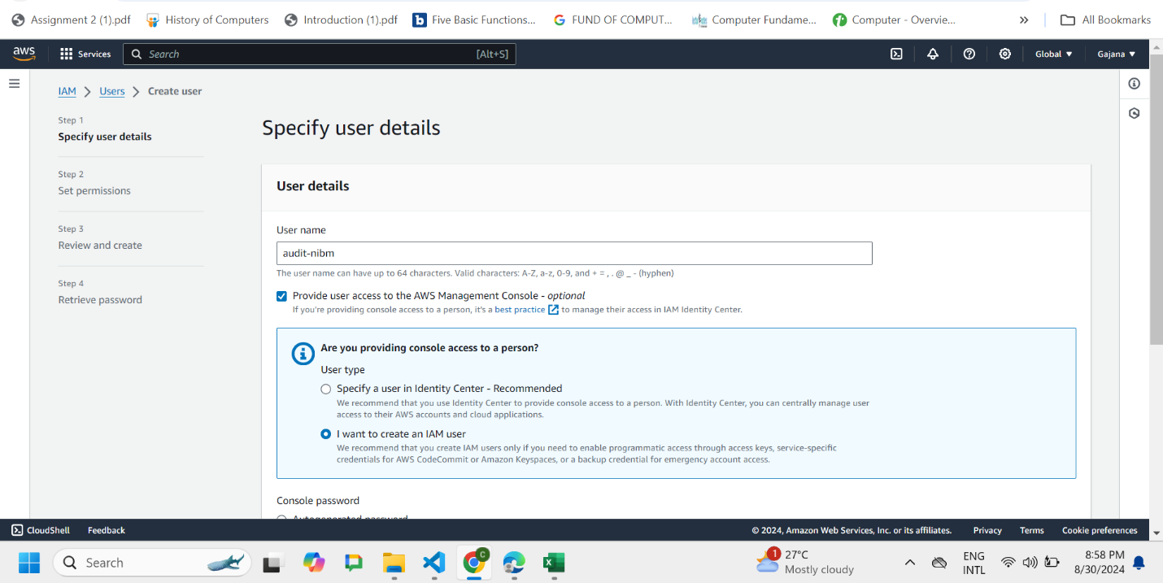

Figure 42: User details

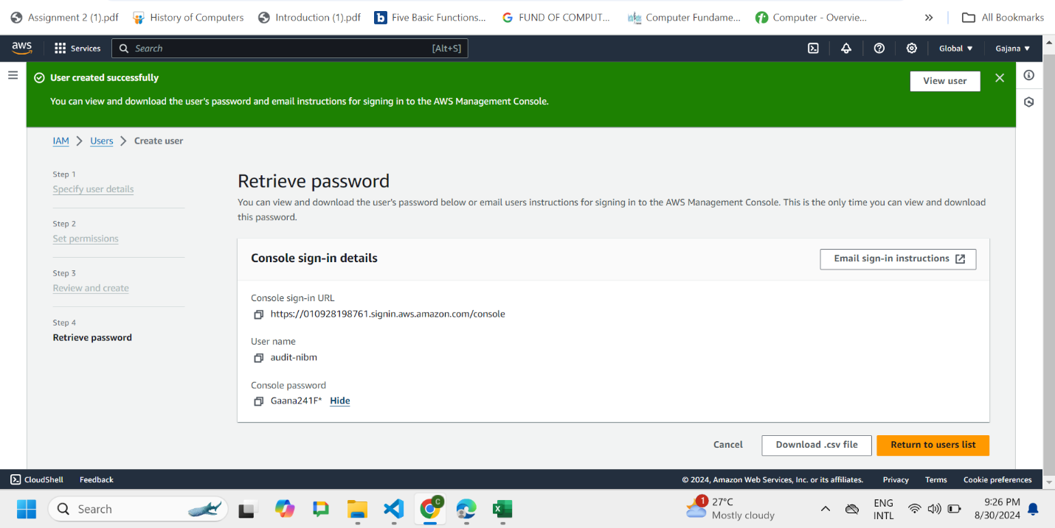

Figure 43 :User created successfully

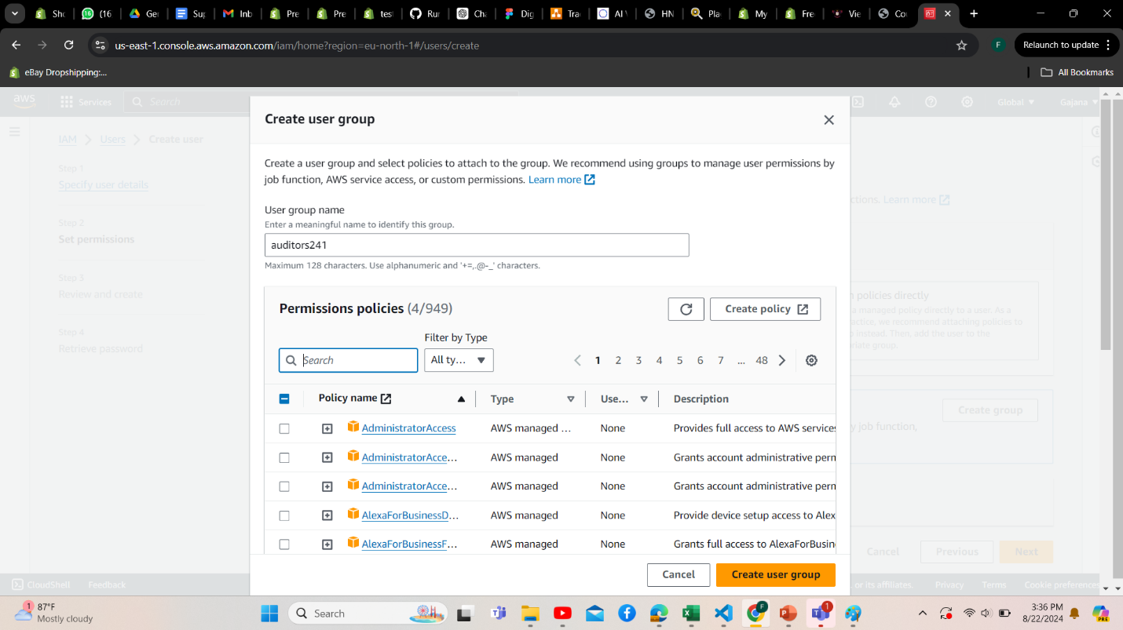

Figure 44: create user group and permission policies

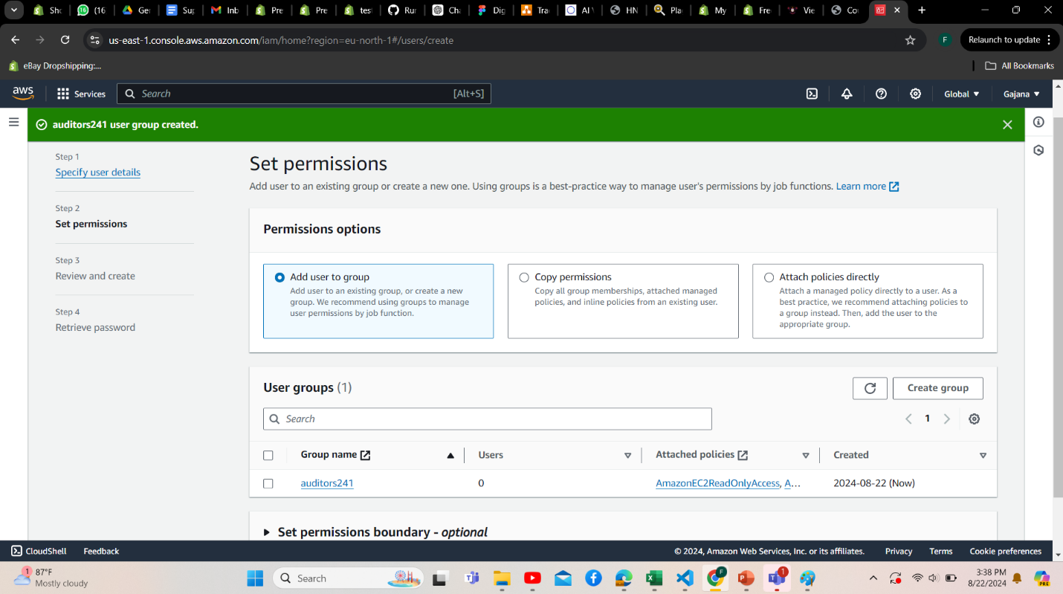

Figure 45: permission set successfully for user group

|  |  |
| --- | --- |
| Sign-in URL for IAM users in this account | https://gaanaadmincw-1.signin.aws.amazon.com/console |
| Username | Adminfullaccess |
| Password | GaanaAdmin*46 |

Table 4:URL for IAM users in this account

## C) Why a group is preferred over directly granting permissions to a user

It is better to handle permissions as a group rather than giving them to specific users since it increases efficiency and security. Any user joined to a group immediately gets the permissions that are assigned to that group. This method simplifies the management of access rights, particularly in large companies when a significant number of users have comparable authorization requirements.

For example, All users within a group created for "Developers," for instance, can instantly gain access to development resources. As soon as a new user joins the development group, all of their permissions are immediately granted by adding them to the group. On the other hand, if a user is removed from the group, their permissions will be removed without requiring changes to individual settings. The possibility of inconsistent administration or human error, skipping to update rights for a particular user is lowered.

Also, by guaranteeing that users only possess the rights required for their roles, employing groups upholds the Principle of Least Privilege (PoLP). Because permissions are consistent among groups, this method also simplifies safety and auditing procedures by making it simpler to monitor and manage access throughout the company.

## d. Principle of Least Privilege (PoLP) in cloud security and its impact on minimizing potential security threats

A key security principle known as the Principle of Least Privilege (PoLP) limits user, system, or process access permissions to what is required for them to carry out their designated tasks. This idea is essential for reducing the possibility of data breaches, unwanted access, and accidental waste of resources in cloud systems.

Consider a worker in a cloud-based organization, for instance, who needs access to a specific database in order to produce reports. Rather than providing the employee with complete administrative access to the whole database system, PoLP specifies that the employee be granted read-only access to the particular tables or views that are essential to their employment. Because the attacker would only have

restricted access, even if their credentials were compromised, the possible harm would be reduced.   
Because cloud settings frequently include a large number of users, services, and interconnected systems, using PoLP in cloud security is essential. The attack surface is greatly decreased by making sure that every entity only has the minimal number of permissions required.

## E) Points to improve the security of your website hosting setup created in the previous question

**Implement HTTPS**: To ensure secure connection between users and the server and prevent data from being accessed or altered during transmission, utilize SSL/TLS certificates.  
  
**Enable Web Application Firewall (WAF**): Install a WAF to monitor and filter HTTP requests in order to shield the website from typical online threats including cross-site scripting (XSS) and SQL injection, as well as other vulnerabilities listed in the OWASP top 10.  
  
**Update and patch software frequently**: To reduce known vulnerabilities, make sure the server, CMS, and any extensions or dependencies are all up to date with the most recent security updates.  
  
**Turn on Multi-Factor Authentication (MFA)**: To provide a higher level of protection beyond a username and password, MFA should be required in order to access the servers or admin panels.

## F) Observability and Accountability with examples and Audit trail in cloud services

**Observability**

Observability In cloud computing, data collection, analysis, and visualization from systems to figure out their internal status are practices. It provides a complete overview of a system's performance, going beyond simple monitoring. Three important pillars work together to provide observability:

* 1. Metrics: These are numerical metrics, such as CPU, memory, or network traffic, that show how well the system is doing. For instance, AWS's Amazon CloudWatch offers metrics that let you keep an eye on the functionality and condition of your cloud resources.
  2. Logs: Detailed recordings of system events, including transactions, faults, and user activity, are kept in logs. These logs provide a timeline of events that occurred prior to, during, and following an event, which aids in identifying the issue. One service that can compile and examine log data from different AWS services is AWS CloudWatch Logs.
  3. Traces: In a distributed system, traces show the route a request takes across many services, making it easier to identify delays or problems. This is especially helpful for architectures that leverage microservices. For example, AWS X-Ray has tracing features that let you see how requests move through your application.

Observability enables developers and cloud administrators to actively detect and fix problems, enhance system performance, and guarantee reliability by combining these elements.

**Accountability**

In cloud security, accountability guarantees that any activity made in a cloud environment can be linked to a particular person or system. Enforcing security policies, controlling user benefits, and conducting incident investigations all depend on this idea. Accountability procedures, for example, make sure that the person responsible for a data breach can be found, so that the right steps, like canceling access or starting a security review, may be taken.

**Audit trail**

A chronological log of all operations or modifications made within the cloud environment is called an audit trail in cloud services. It keeps track of who carried out an activity, what it was, when it was carried out, and how it was carried out. Operational, security, and compliance audits require this kind of thorough documentation. For instance, AWS CloudTrail logs API calls made to AWS services and offers a thorough audit trail that includes information about the requester's IP address, the time of the request, and the actions taken. This makes it possible for businesses to examine and evaluate every move, guaranteeing accountability and openness and making it easier to identify and look into any illegal or suspect activity.

# References

I. “FREE IEEE Citation Generator [Updated for 2020],” MyBib.

<https://www.mybib.com/tools/ieee-citation-generator>

II. “Global, regional, and zonal resources | Compute Engine Documentation,” Google Cloud.

<https://cloud.google.com/compute/docs/regions-zones/global-regionalzonalresources#:~:text=For%20example%2C%20global%20resources%20are>

III. “What is Network Segmentation? Virtual & Physical Segmentation | UpGuard,” [www.upguard.com](http://www.upguard.com).

<https://www.upguard.com/blog/what-isnetwork-segmentation>

IV. AWS, “Shared Responsibility Model - Amazon Web Services (AWS),” Amazon Web Services, Inc., 2019.

<https://aws.amazon.com/compliance/shared-responsibility-model/>

V. Zola, “What Is a Ping and How Does it Work?,” TechTarget, Jul. 2021.

<https://www.techtarget.com/searchnetworking/definition/ping>